Lab 15: Backdooring with Netcat

Marko Shaffer

Information Security, Franklin University

ISEC 325: Comm/Network Security

Professor Rick Rozzell

7 / 18 / 2021

# **Lab 15: Backdooring with Netcat**

## Follow the instructions from “Lab 08: Password Cracking with John the Ripper and Hashcat.”

* + Note: For all of the screenshots in the following steps, make sure to include the entire browser window to show that you are logged in to Netlab.

## Start with Section 1, “Port Scanning with Netcat,” and capture a screenshot of the following:

### Step 6 output

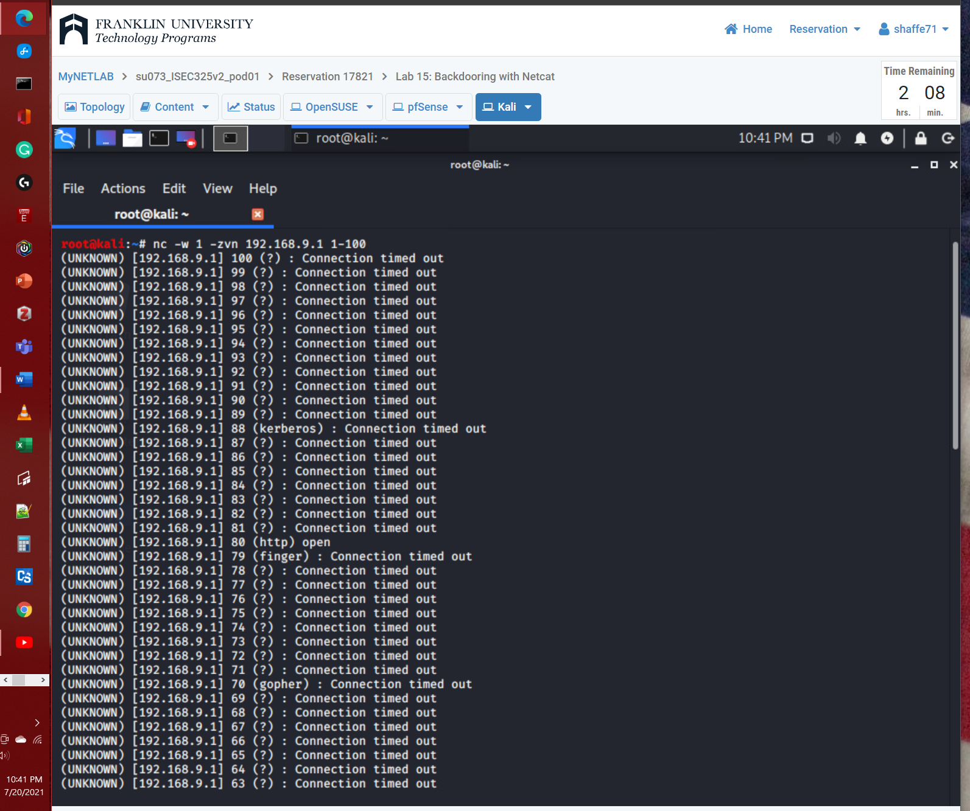

## Continue with Section 2, “Establishing Connections with Netcat,” and capture a screenshot of the following:

### Step 11 display

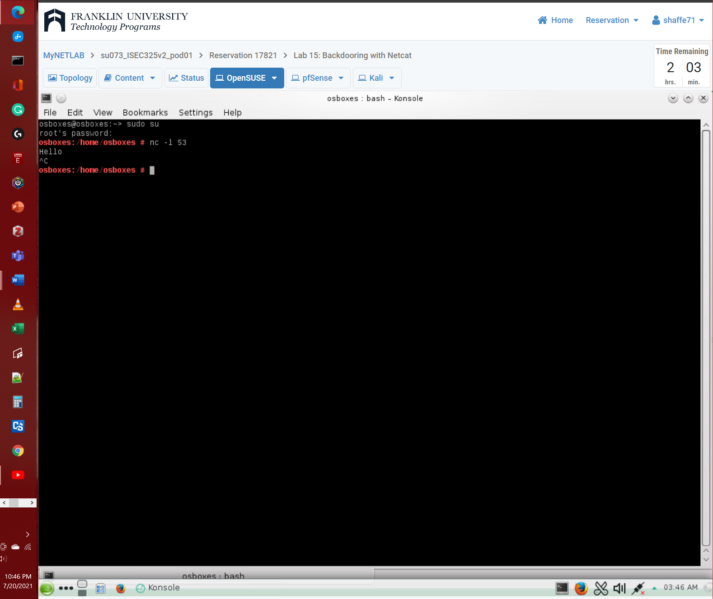

## Continue with Section 3, “Transferring Files with Netcat,” and capture a screenshot of the following:

### Step 10 file list

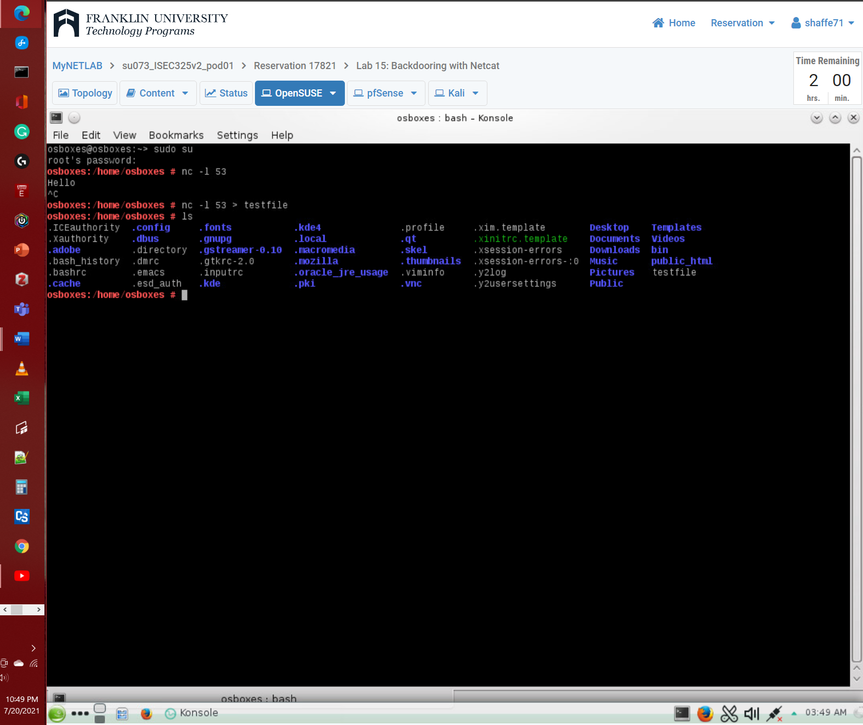

## Summary and Reflection: In a few paragraphs, reflect on what you learned through this lab assignment. Was there anything surprising or unexpected? Was there anything worth investigating further?

In lab 15 we learn how to setup a connection between 2 computer with a firewall between them. Using netcat we can scan a range of outward facing ports or firewall ports. Setup the reciving pc to listen on a open port using netcat. On the sending computer initiate session using the reciving computers ip and port it listening on. Then just type your message and it will passthrough the firewall since it open. The next thing we learn is how to implement this same method to transfer a file. I wounder how much this is used and if it would be loged weird in the firewall? Which is a question I plan to look into.

# **References**